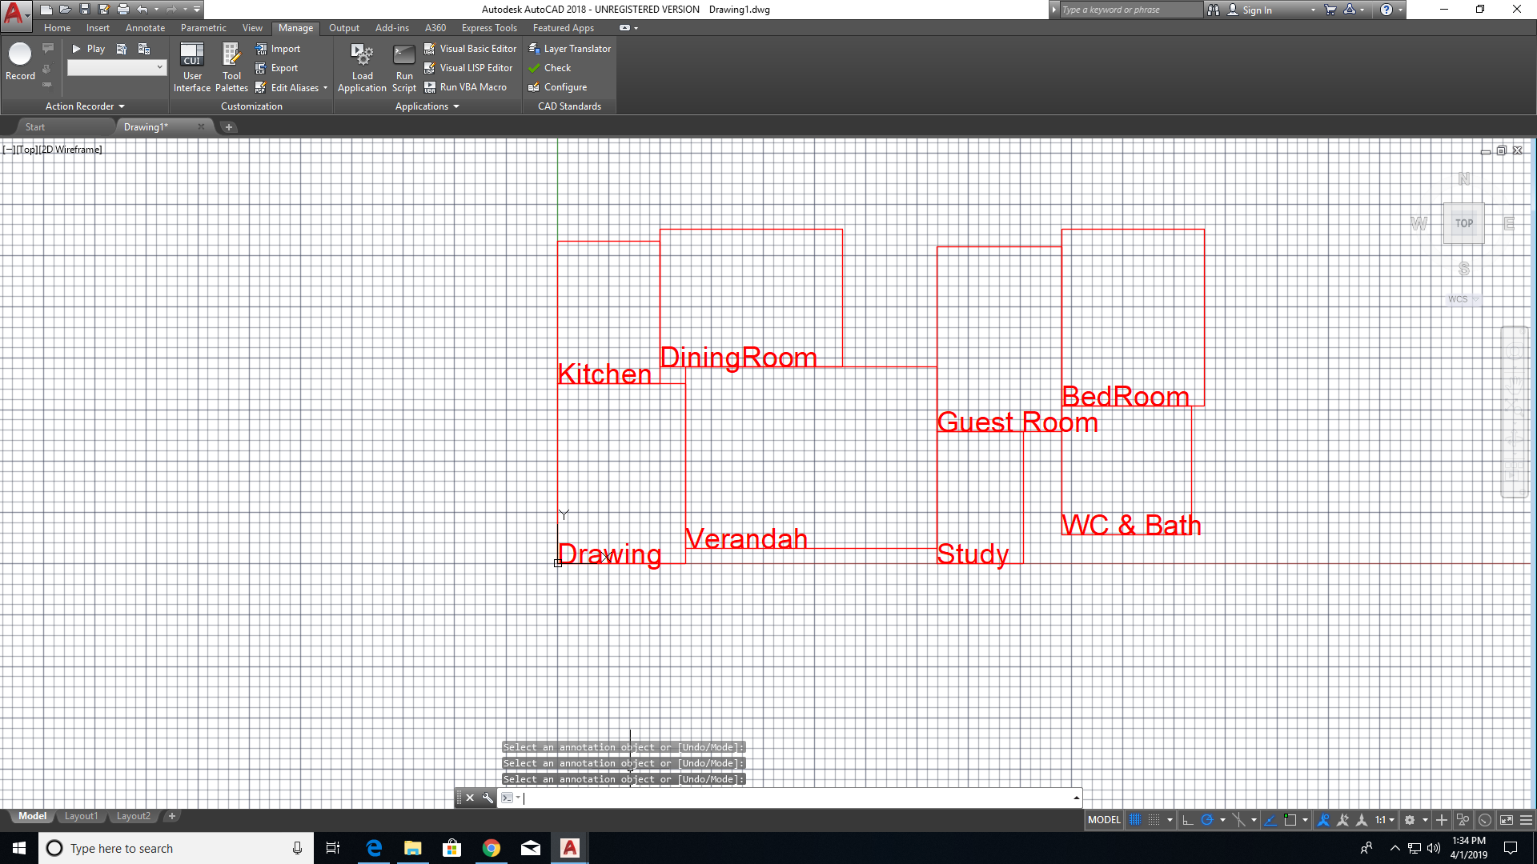

100Unique Fitness Population 1

161.172

171.785

max fitness_value chromosome 184.85184.85(((6 2) (3 5) (4 7) (0 1)) ((6.21955 4.99001) (8.88629 12.2474) (4.19893 6.0642) (6.95531 6.29591)) ((8.75414 6.95173) (6.73547 8.81952) (6.44373 8.99082) (8.62773 6.27446)))(6.21955 4.99001 8.88629 12.2474 4.19893 6.0642 6.95531 6.29591)

(8.75414 6.95173 6.73547 8.81952 6.44373 8.99082 8.62773 6.27446)

((6 2) (3 5) (4 7) (0 1))

((6.21955 4.99001) (13.8763 18.467) (22.6659 24.5312) (31.4865 30.8271))31.4865LArea438.09750.9033

((6 2) (3 5) (4 7) (0 1))184.85

(6.21955 4.99001 8.88629 12.2474 4.19893 6.0642 6.95531 6.29591)

(8.75414 6.95173 6.73547 8.81952 6.44373 8.99082 8.62773 6.27446)